Bell ringers ART week 3

Monday
Try to copy the image to the best of your ability.
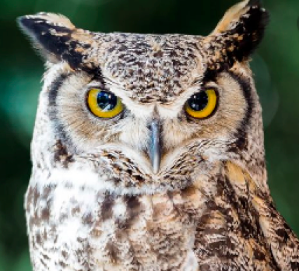

Tuesday
Draw a turkey.

