Pen and Ink Final Project

Name_____________________________________________ period______________ date________________
Directions: The purpose of this project is for you to create art that has meaning and purpose. The art piece must reflect your opinion about an important issue. It may be a topic we discussed in class or a topic of your choosing.
- You chose an issue of importance to you.

The issue of importance I have chosen is

- Write a 3-5-sentence artist statement. Why did you choose this issue? Why do you think it is important?
Artist statement: ________________________________________________________________________________________________________________________________________________________________________________________________________________________________________________________________________________________________________________________________________________________________________________________________________________________________________________________________________________________________________________________________________________________________________________________________________________________________________________________________________________________________________________________________________________________________________________________________________
- Brainstorm three thumbnail sketches. Remember, it is better to have a large, simple, single subject, HIGH quality drawing than a bunch of scattered, small poor quality images.

- Find an actual photograph to use as a reference for drawing.

- Draw the image LIGHTY in pencil on the large paper.

- Use the ink pen and do shading techniques practiced in class. (hatching, cross hatching, scribble technique.)
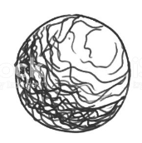
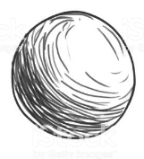
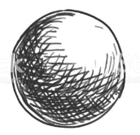

Hatching cross hatching scribble technique

