Bell Ringers week 2

Monday
Draw an ocean creature.

Tuesday
What does the following image mean?
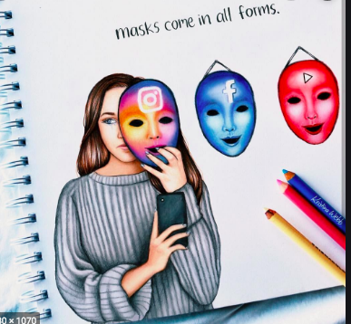

Wednesday
Draw a mountain landscape.

Thursday
Copy the image to the best of your ability.
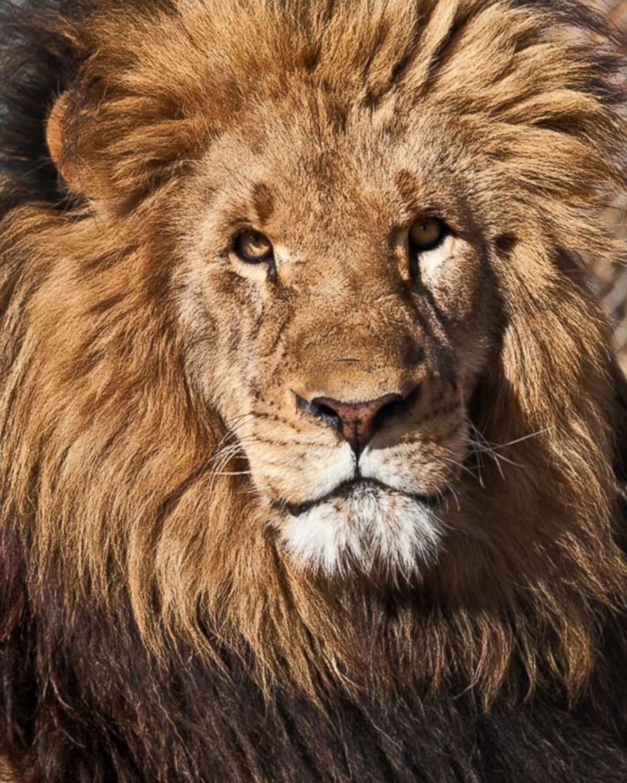

Friday
Use a fancy/creative font to write the words hello friend.

hello friend hello friend hello friend

