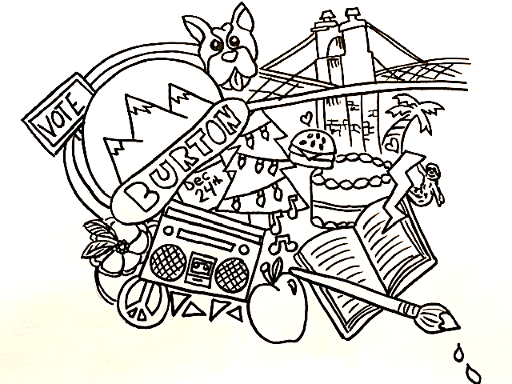
Name___________________________________________ Date_____________ Period________
(First and Last)

Directions for Doodle Collage

You will be creating a collage of images that represent you. Each image you choose to draw in your work should be an item that reflects something about yourself. For example, I may choose to draw items that reflect things I am interested in such as a book for reading, a snowboard, a concert ticket etc. I may also choose to draw items that represent something such a tree to represent the fact that I like nature, a heart to represent the love I have for my family, or an apple to symbolize my healthy eating habits. I may choose to add a sloth because it’s my favorite animal and I think it’s cute. These are items that represent me and my personal interests in a visual way. You need to come up with your own items to represent you. Please view the example(s) on the board.

Please Review the rubric because you will be graded in the following categories.
PAY ATTENTION TO THE UNDERLINED SECTIONS BECAUSE THEY ARE WORTH THE MOST POINTS.

Rubric for Doodle Collage | Student  Self score | Possible points | Final grade
Composition takes up most of the page. There is little negative space. |  | 20
Student included at least 10 images to reflect personal self and interests. |  | 30
Student artwork is neat and clean. Student put forth best effort. |  | 20
Student used time wisely in class and stayed on task. |  | 10
Student used materials appropriately. Student outlined images in ink pen or thin marker. |  | 10
Student participated in presentation of artwork and/or self-reflection. |  | 5
Student participated appropriately in class critique. |  | 5
Total |  | 100

Definition of composition: ________________________________________________________________________________________________________________________________________________________________________

Learning targets:
*
____________________________________________________________________________________*_______________________________________________________________________________________________________________________________________________________________________*_______________________________________________________________________________________________________________________________________________________________________

Make a list of the 10 items you will include in your collage AND include the reason you are choosing them to represent yourself.
Image | Reason why you are including it in your artwork
1.

2.

3.

4.

5.

6.

7.

8.

9.

10.

