Bell Ringers Week 4

Monday
Draw a sweet treat.

Tuesday
Give this image a creative title.

Wednesday
Draw a fish

Thursday
Copy the image.
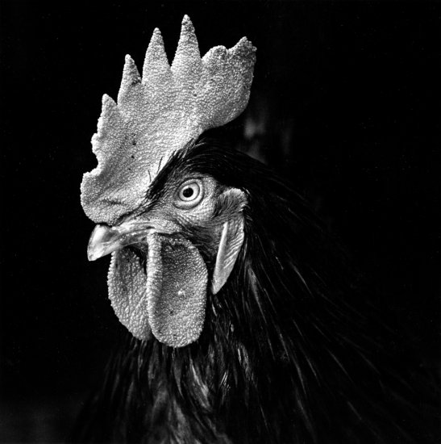

Friday
Draw something broken.

