Name_____________________________________________ Period__________Date___________
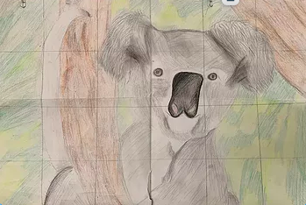
Animal Colored Pencil Drawing

Directions:
Step 1: Choose a photograph of animal you think reflects your personality. This must be a realistic animal drawing and you must have realistic photograph reference to draw from.
Step 2. Write your 3-5 sentence paragraph explanation on why you chose the animal.
Step 3. Graph the photo: The photograph must be graphed in squares. If you are using a device to graph your image, use “grid#” app on Apple devices and use “Artist Grid” app on androids. Make sure you adjust the settings so the grid lines are square.
Step 4. Graph your paper you are drawing onto with larger squares lightly in pencil.
Step 5. Draw your image onto the paper.
Step 6. Color your artwork with colored pencils. Remember to use different colors and attempt realistic shading techniques, blending, and or create textures.

Animal colored pencil drawing rubric | Student  Self score | Possible points | Final grade
Composition takes up most of the page. There is little negative space. |  | 20
Student artwork is neat and clean. Student put forth best effort. |  | 20
Student used materials appropriately. Student attempted shading, textures, and/or blending with colored pencils. |  | 20
Student accurately graphed image. |  | 20
Student drew an image of an animal that represents them. |  | 10
Student participated in self-reflection/artists statement. |  | 5
Student participated appropriately in class critique. |  | 5
Total |  | 100

ANIMAL ART PIECE EXPLANATION

Name the animal you have selected for your art piece. Explain why you are choosing to draw the animal and how it reflects your personality. Write 3-5 complete sentences with proper capitalization and punctuation.
___________________________________________________________________________________________________________________________________________________________________________________________________________________________________________________________________________________________________________________________________________________________________________________________________________________________________________________________________________________________________________________________________________________________________________________________________________________________________________________________________________________________________
___________________________________________________________________________

