Art Bell Ringers Week 10

Monday
Draw an alien

Tuesday
Draw something to represent determination.

Wednesday
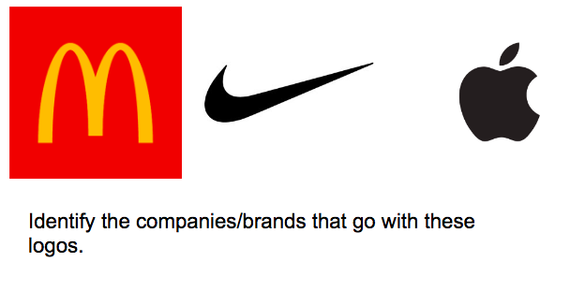

Thursday
What is a logo?

Friday
Draw a food item.

