Pen and Ink practice

Name__________________________________________________________ period_________ date____________

Hatching

Cross hatching

Scribble technique

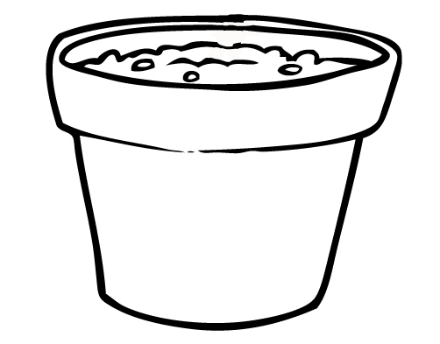
Hatching

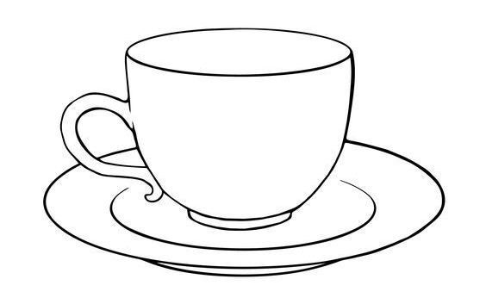
Cross hatching

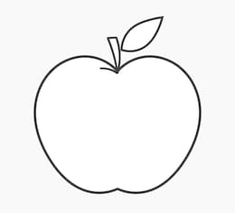

Scribble technique

